**Exercise 5-3 YOLO on colab**

Jirayu Petchhan, D10907801

**Image testing**

Image for testing (figures same as previous exercise)

|  |  |
| --- | --- |
| Segmentation Type | Image |
| Scale | C:\Users\e_user\Downloads\20201124_4-3\Scale_human.jpg |
| Pose (motion, Viewpoint) | C:\Users\e_user\Downloads\20201124_4-3\human_run.jpg |
| Occlusion | C:\Users\e_user\Downloads\20201124_4-3\human_oclusion.jpg |
| Multiple | C:\Users\e_user\AppData\Local\Microsoft\Windows\INetCache\Content.Word\threemandown.jpg |

Upload and run dataset, pretrained-model, & image predicted

Scale

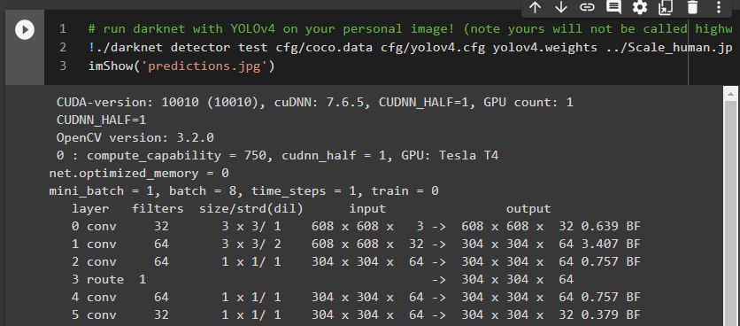

…

**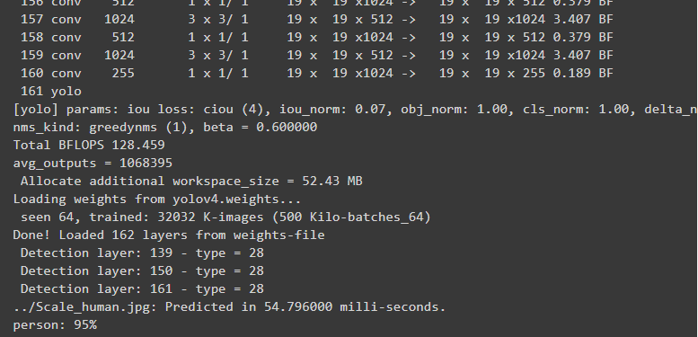**

Moving

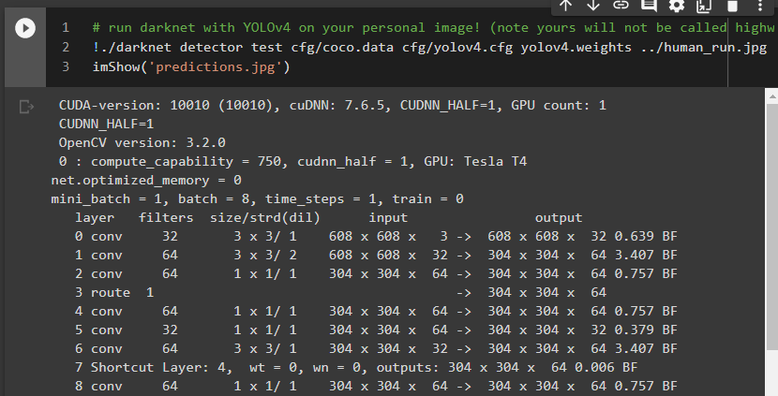

…

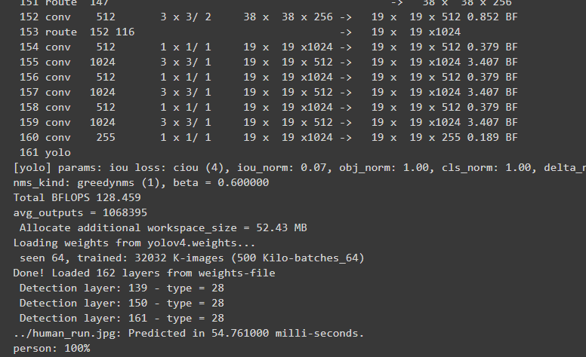

Occlusion

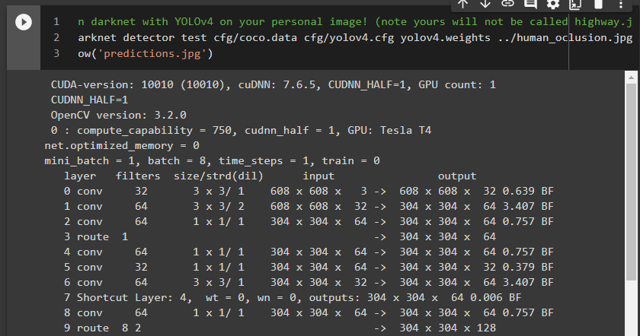

…

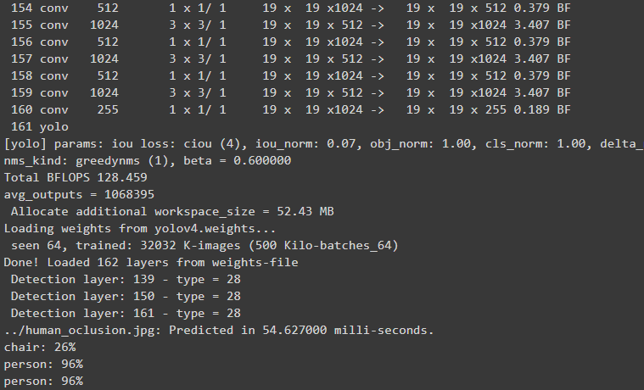

Multiple

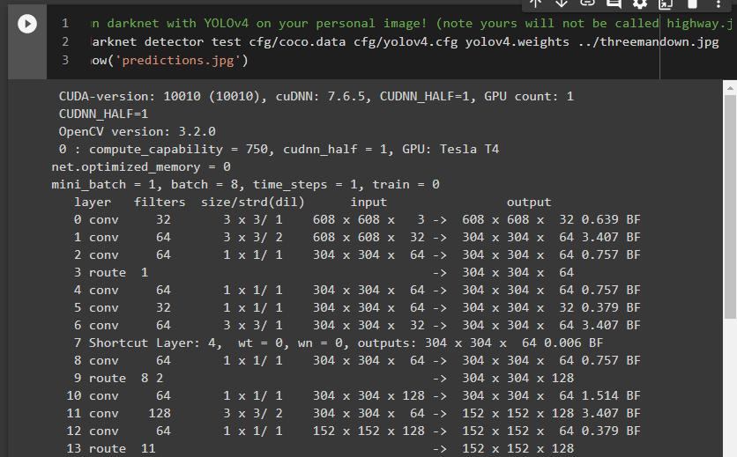

…

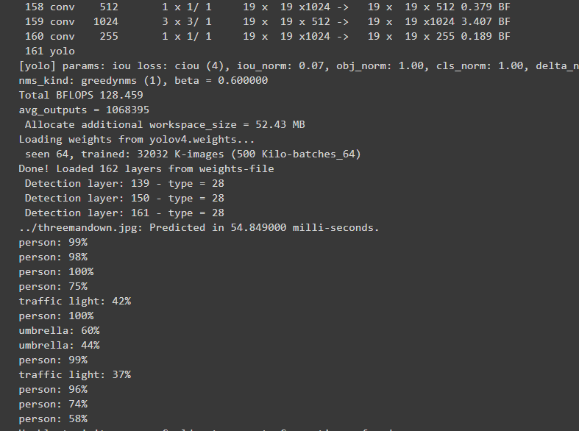

Image after object detecting on YOLO (Default setting)

|  |  |
| --- | --- |
| Segmentation Type | Image |
| Scale |  |
| Pose (motion, Viewpoint) |  |
| Occlusion |  |
| Multiple |  |

**Video testing**

Changing video

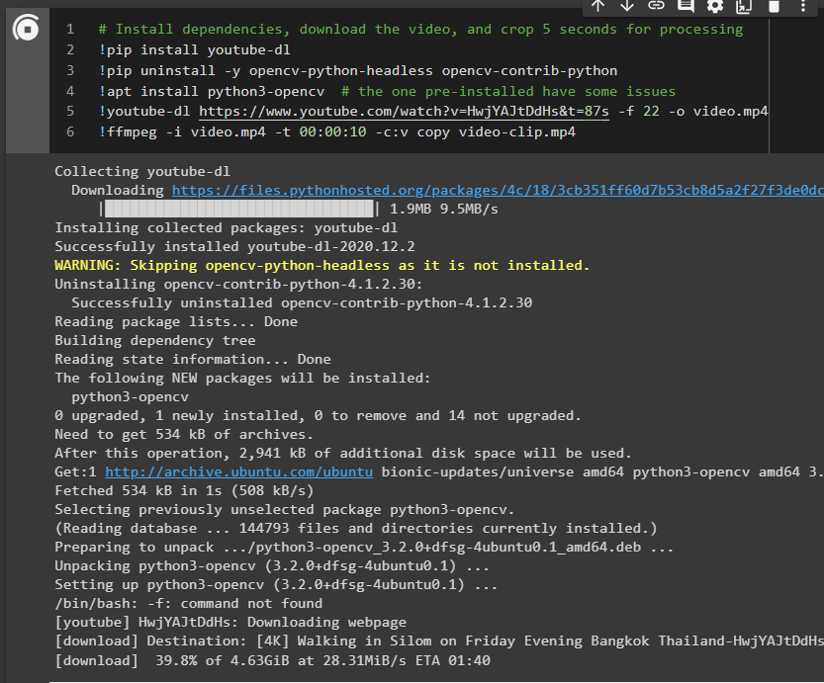

Optional step - Upload from local M/C

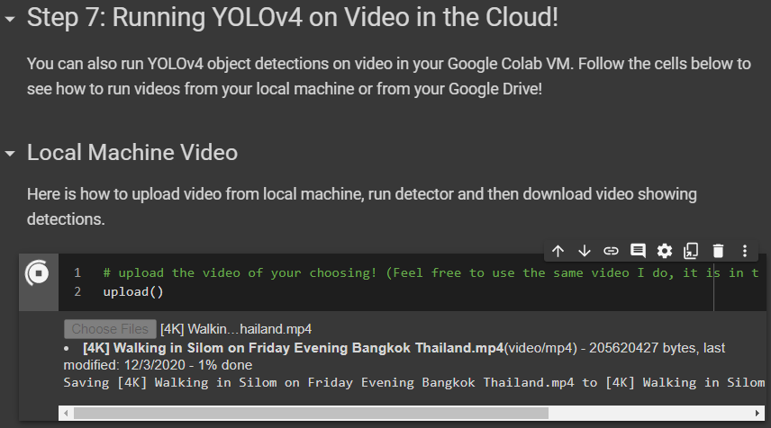

Train (Default setting)

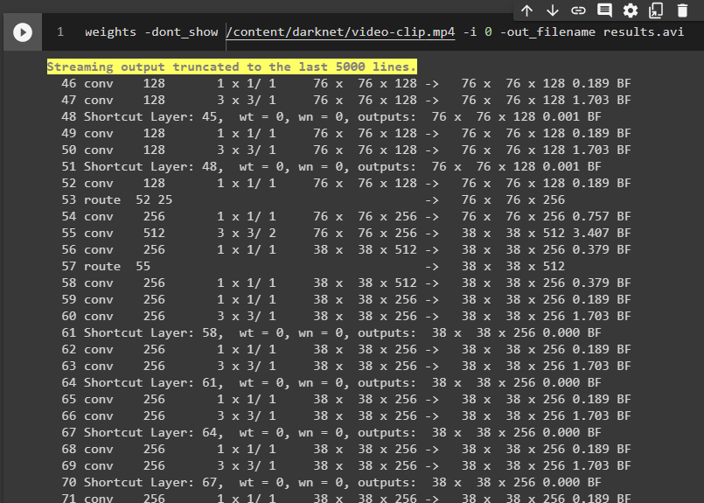

…

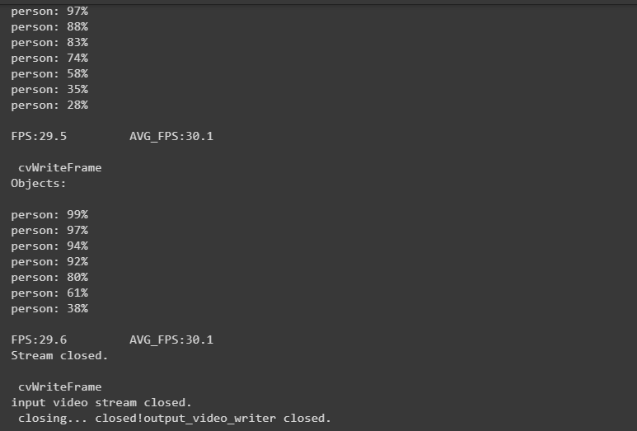

Result

YOLO has detected object detection with the fastest training step because it might me single-stage detection when comparison with Detectron2 has detection of human pose and interpete to skeleton and key points on the human.

By the YOLO result of the video which has been attached in the file.

Attached file name (result\_YOLO\_default.avi)

**Change pre-trained model**

# changing parameters

!./darknet detector demo cfg/coco.data cfg/yolov4-custom.cfg yolov4.weights -dont\_show /content/darknet/video-clip.mp4 -i 0 -out\_filename results.avi

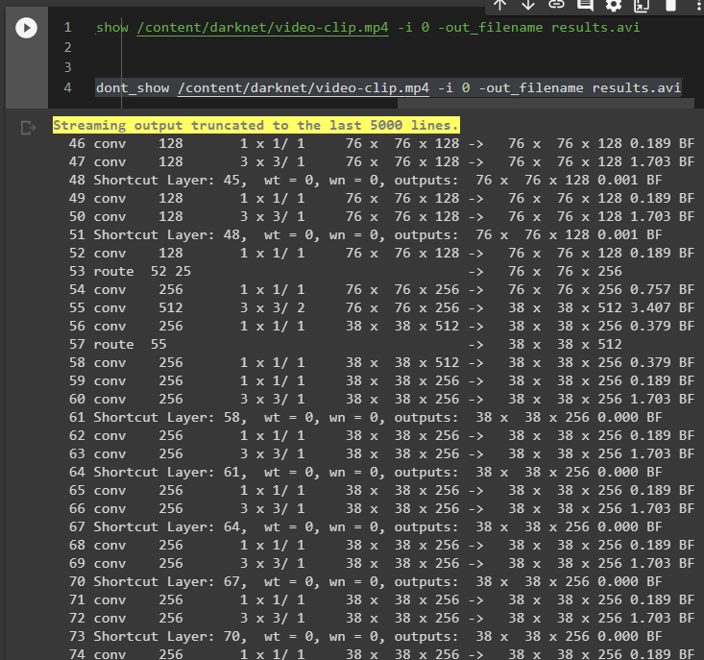

…

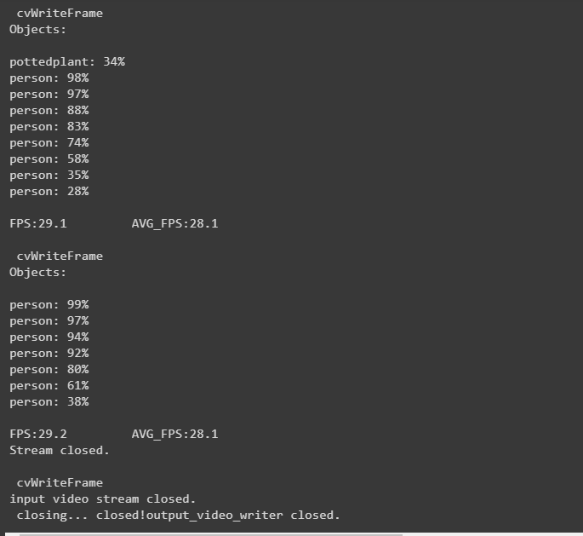

Result

Comparison result between pre-trained YOLOv4 default and YOLOv4-custom

By the YOLOv4-custom result of the video which has been attached in the file.

Attached file name (result\_YOLOv4\_custom.avi)

**Threshold flag**

Default setting

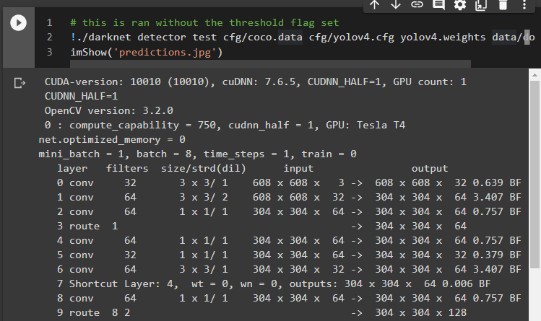

...

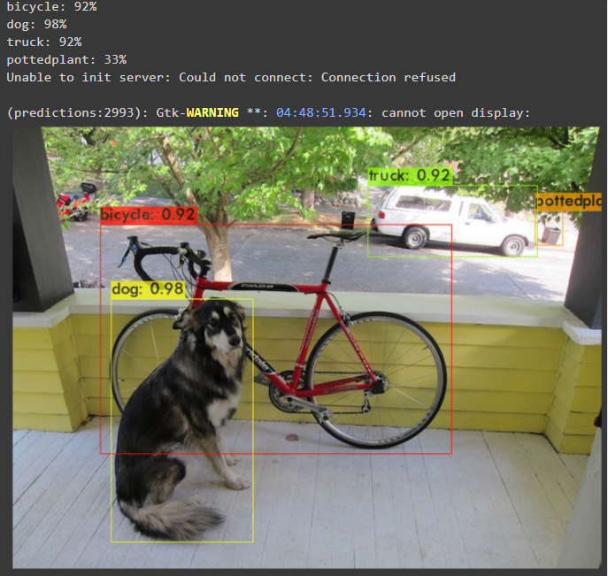

Changing setting to threshold = 0.5

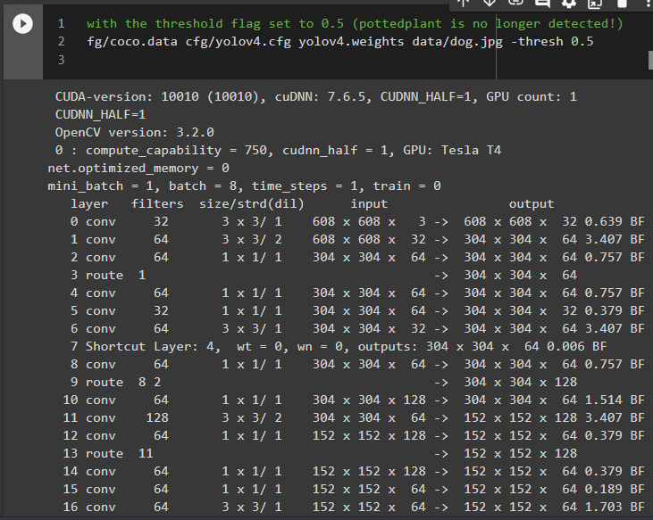

…

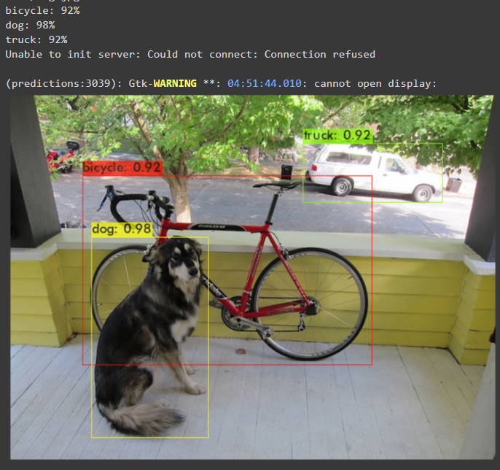

Changing setting to threshold = 0.1

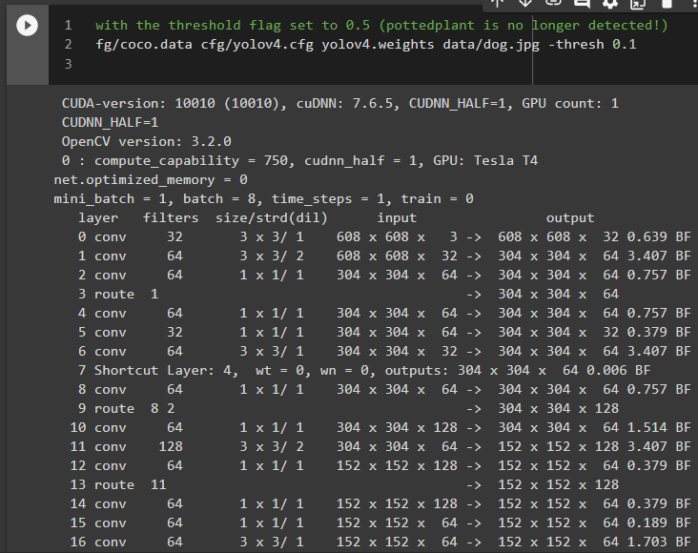

…

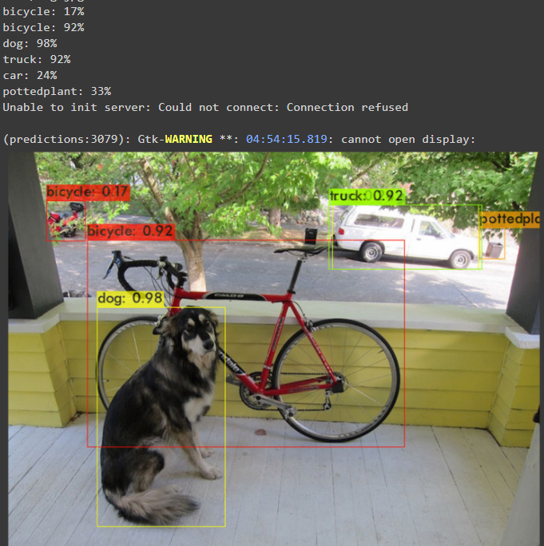

**Multiple Images at Once**

images.txt

./Scale\_human.jpg

./human\_run.jpg

./human\_oclusion.jpg

./threemandown.jpg

./roadncar.jpg

Note similar to test image in single prediction

Coding

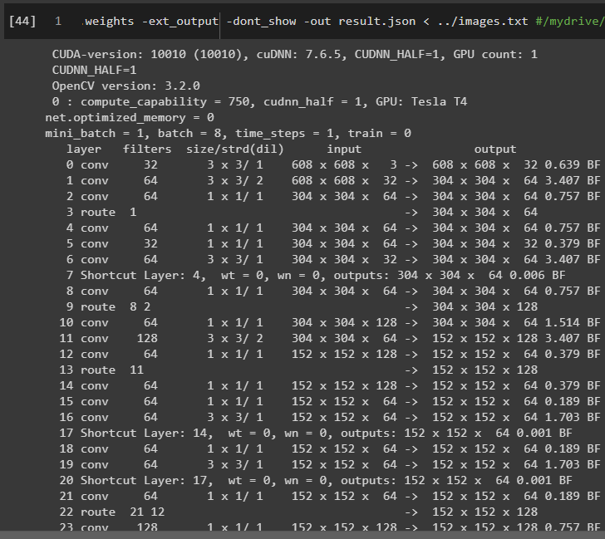

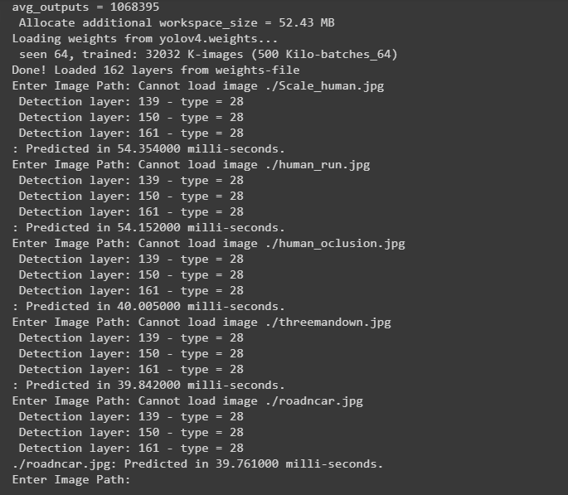

Result

Attached file name (result.json)